SPH4U0 Data Analysis Quiz-#1 Name:________________________ Total: ____/26 marks [K]

1.Give the number of significant digits in each of the following measurements: [3]

1. 135 000 km= ____________ b) 0.005650 s _______ c) 1.0060 x 10 3 m _________

2. How many significant digits are there in a count of 15 swings of a pendulum? Explain your answer. [2]

3. Do the following calculations, rounding off answers to the appropriate number of significant digits. Include correct units in your answer. [3]

a) 152 km + 25.5 km + 8.35 km= b) (5.60 m/s)÷12.345 s = c) 23.55 cm x 9.37 cm x 2.84 cm =

4. Perform the following units conversions, expressing your final answer in scientific notation if necessary.

Show your work. [6]

1. 256 Mm= ? Gm b) 0.00073 µs= ? ms c) 15 000 cm2 = ? m2

5. a) Find the relative (percent) uncertainty in the following time measurement. [1]

Δ t= 15.38 ± 0.02 s

1. Find the total length and the absolute uncertainty: [1]

LTotal = L1 + L2 – L3 , L1= 15.2± 0.2 cm L2=47.3 ± 0.2 cm L3 = 5.4 ± 0.1 cm

1. Find the volume and the absolute uncertainty: [2]

Volume = length x width x height L= 6.34 ± 0.05 m W=3.97 ± 0.05 m H=4.28 ± 0.05 m

6. The table below shows the result of an experiment to investigate the variation of electric field intensity (E) with distance (D) from a point charge. Graph the relationship on the graph paper provided. [3]

|  |  |  |  |  |  |  |  |  |  |
| --- | --- | --- | --- | --- | --- | --- | --- | --- | --- |
| Distance (m) | 0.20 | 0.30 | 0.40 | 0.50 | 0.60 | 0.70 | 0.80 | 0.90 | 1.00 |
| Electric Field Intensity (N/C) | 225.0 | 100.0 | 56.0 | 36.0 | 25.0 | 18.4 | 14.1 | 11.1 | 9.0 |

1. 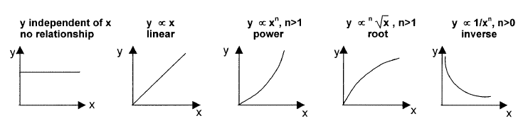Which of the following general relationships best describe this graph? Explain your choice. [2]
2. Describe the steps in the graphical analysis process you would use to determine the expression for the full mathematical relationship that describes this graph. [3]